Department User Guide

Team 8

**Table of Contents**

**Logging Into the System** **2**

**Create Stationery Request Form** **4**

**View Order Status(Employee)** **6**

**Approval of Stationery Request Form** **8**

**Browse Product Catalog** **10**

**Disbursement List** **12**

**Saved Orders** **14**

**Create Saved Order** **15**

**Delete Saved Order** **17**

**Request Saved Order** **18**

**Appoint Representative** **19**

**Authorize Staff** **22**

**Set Collection Point** **25**

**Login Screen (Android)** **28**

**Appoint Representative (Android)** **30**

**Authorize Staff (Android)** **32**

**Set Collection Point (Android)** **34**

# 

# Logging Into the System

The system will be accessed via the below page. Please enter the provided credentials into the username and password boxes.

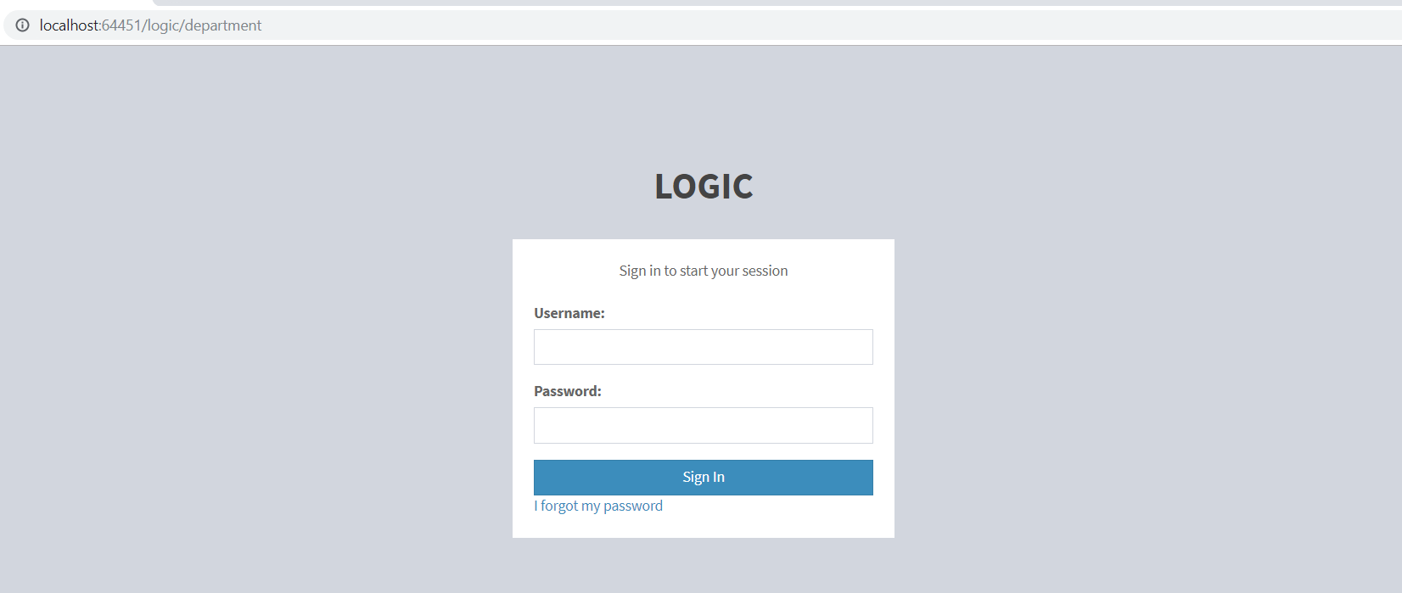

Once you are logged in successfully, you will be presented with the following dashboard (For Department Head). The list of key links will be presented on the left panel.

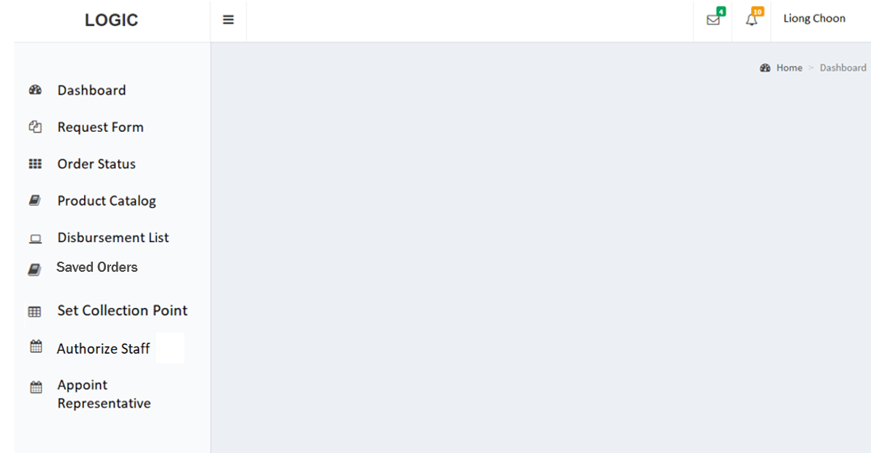

For Department Staff, you will be presented with the following dashboard.

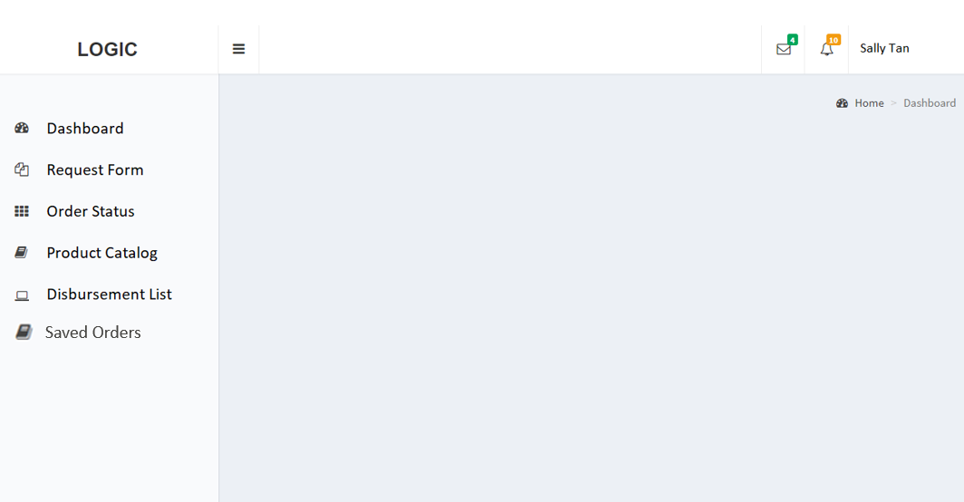

# Create Stationery Request Form

To create a new request form, select the following link from the left panel (Highlighted in Red):

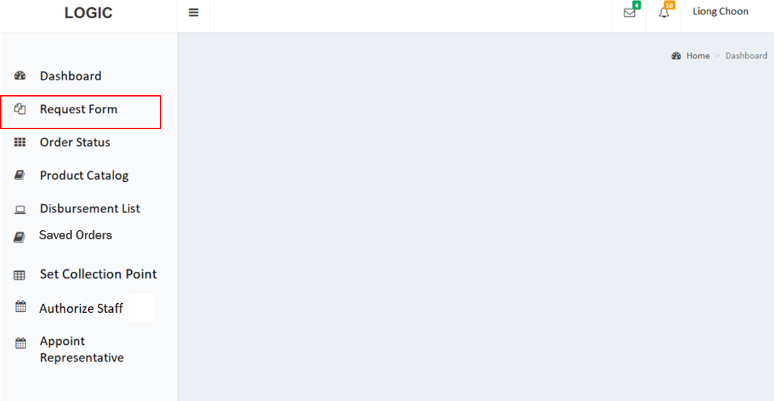

Upon selection of Request Form, the following page will be presented. First choose a category by selecting from the dropdown list. A type-ahead search is also provided and you will be able to type a selected category as well.

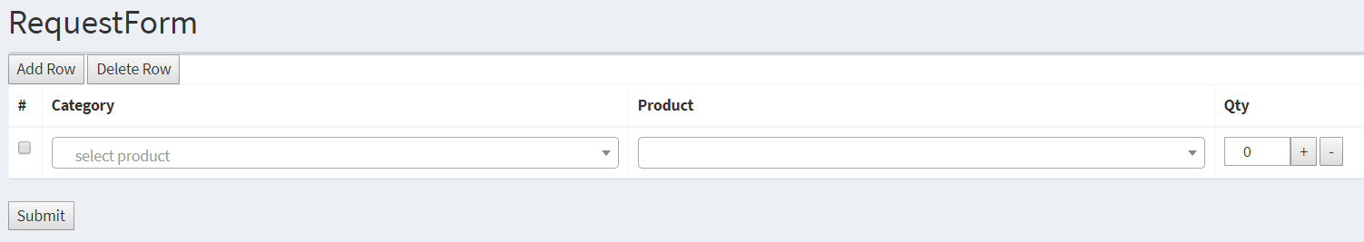

After selecting a category, the related product lists will be loaded. Here you can choose or type your selection easily as shown in the example below.

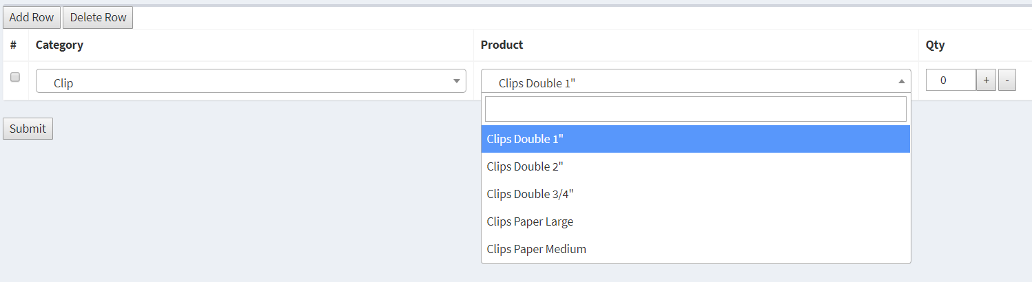

To add more items to the request form, click “Add Row” at the top left.To remove a specific item row, click on the checkbox beside the specific item and click on the “Delete Row” Button on the top left. You will be able to create a stationery request form as shown below.

To adjust quantity for each item, simply click on the “+” and “-” signs or type in the required quantity in the box.

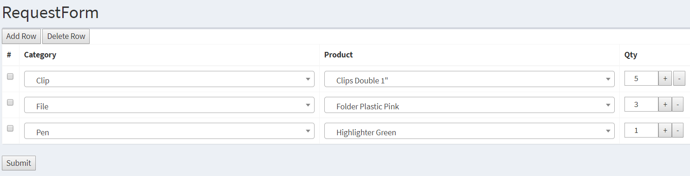

Once all items have been entered, click “Submit” at the bottom to finish the creation of the form.

# 

# View Order Status(Employee)

To view order status, select the following link from the left panel (Highlighted in Red):

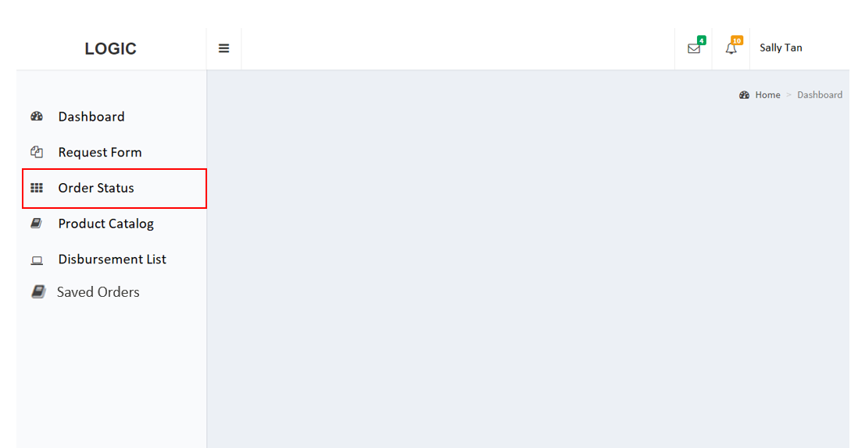

Upon selection of “Order Status”, the following page will be presented. Upon clicking “Details”, a full detail of the order will be presented.

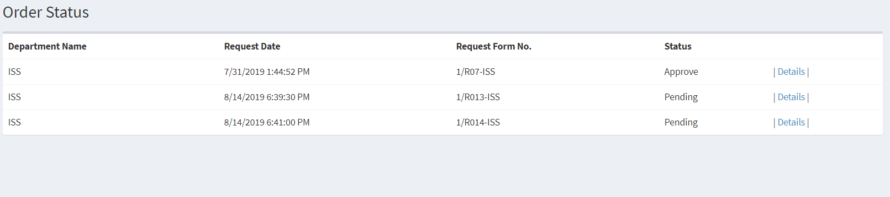

Here is the detail page. It will show Order Status “Pending” or “Approved”, as well as the items and quantity ordered.

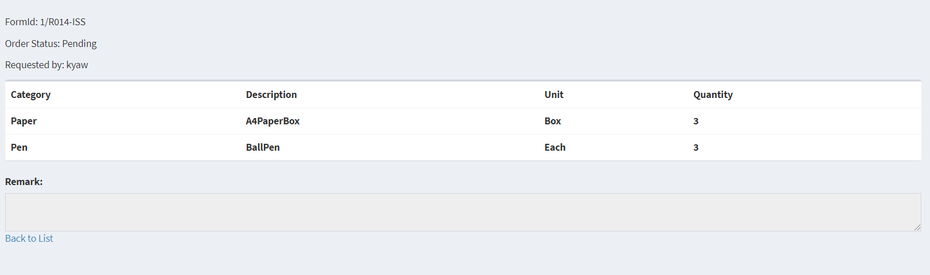

# 

# Approval of Stationery Request Form

For the department head to approve or reject a request, select the following link from the left panel (Highlighted in Red):

# 

Upon selection of “Order Status”, the following page will be presented.

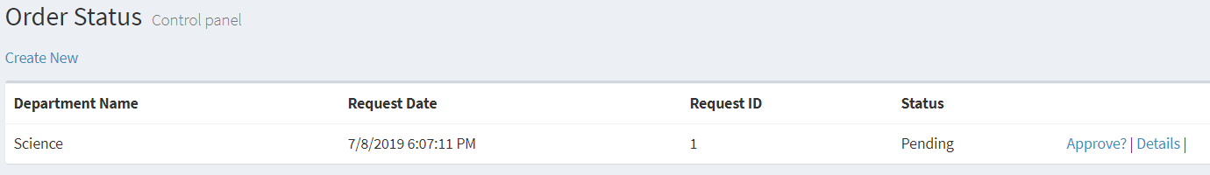

Upon clicking “Approve?”, the following page will be presented.The view would consist of an input box that would allow for the approver to be able to input their remarks. Upon clicking the approve or reject button would approve or reject the request.

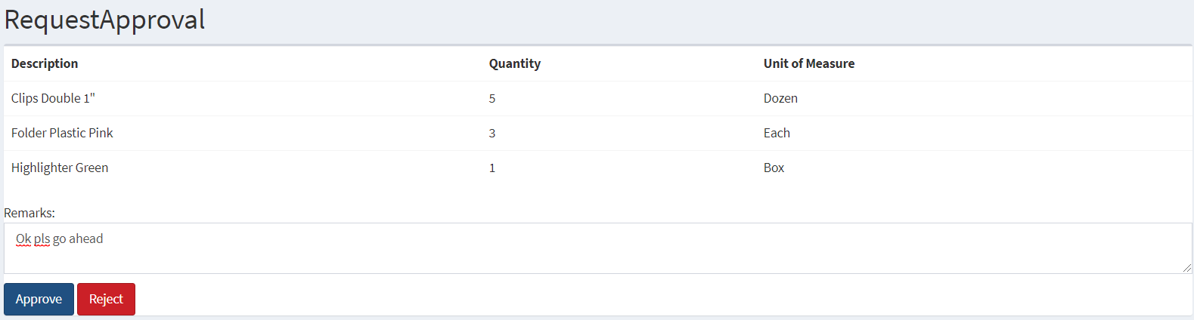

Upon making a choice of “Approve” or “Reject”, the status of request on the Order Status page would be updated accordingly.

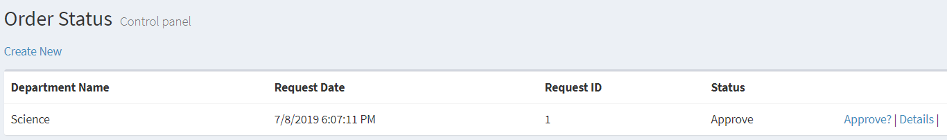

Upon clicking “Details”, a full detail of the order will be presented and also the status would reflect accordingly.

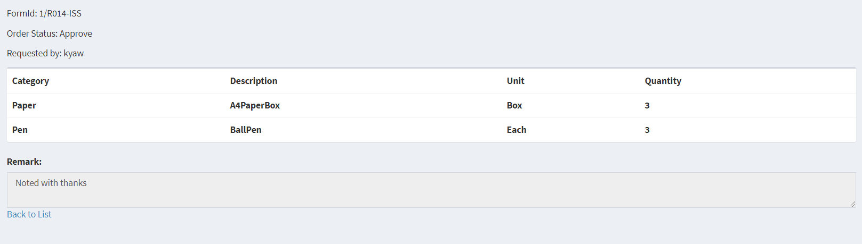

# 

# Browse Product Catalog

To browse product catalog, select the following link from the left panel (Highlighted in Red):

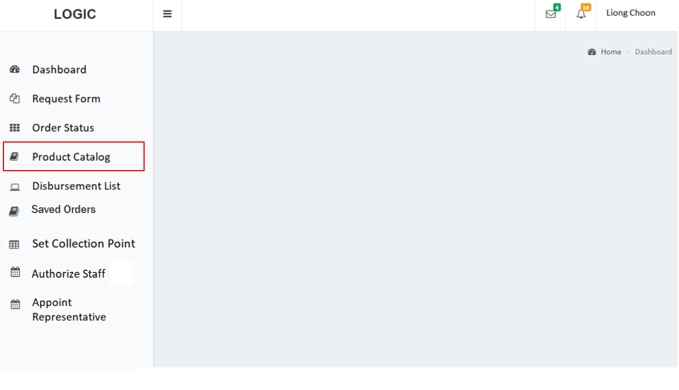

The Product Catalog will be loaded as shown:

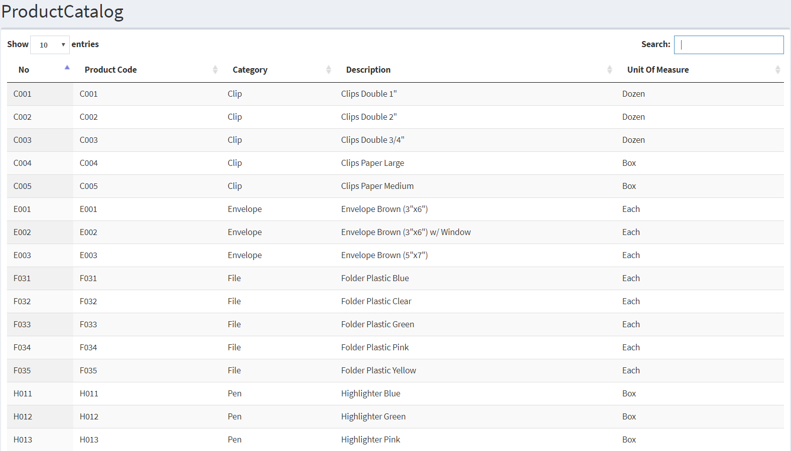

Here, simply type an item that you are searching for in the search box to narrow the results of the item.

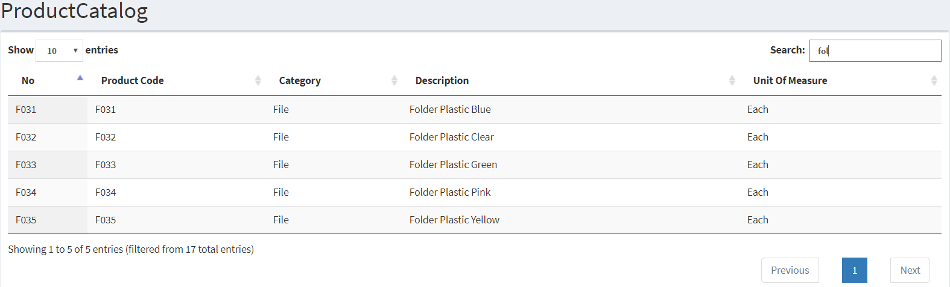

An example of the search for “Clip”:

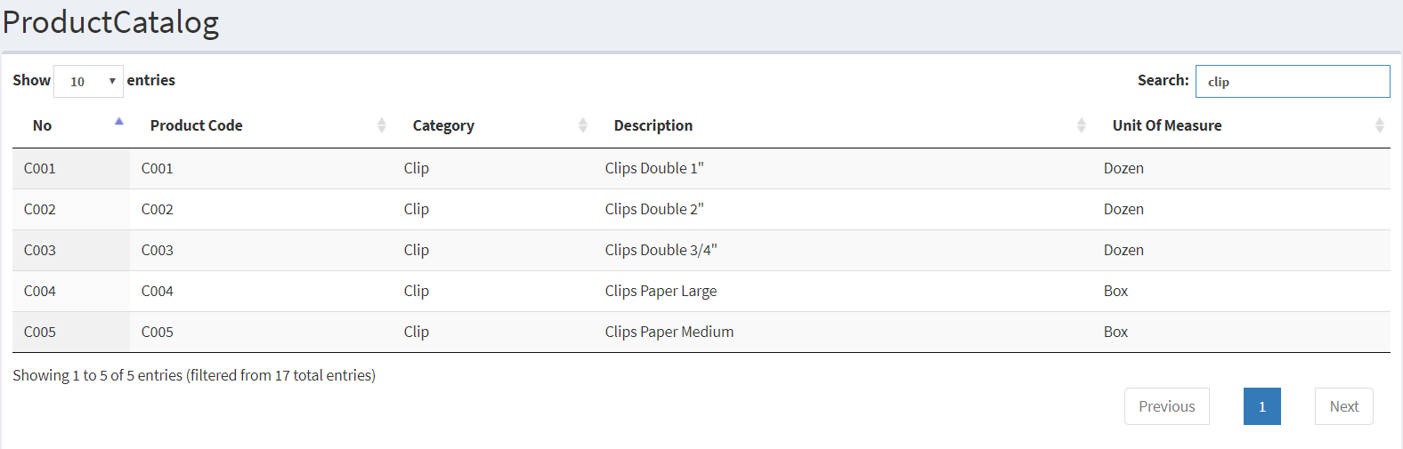

# Disbursement List

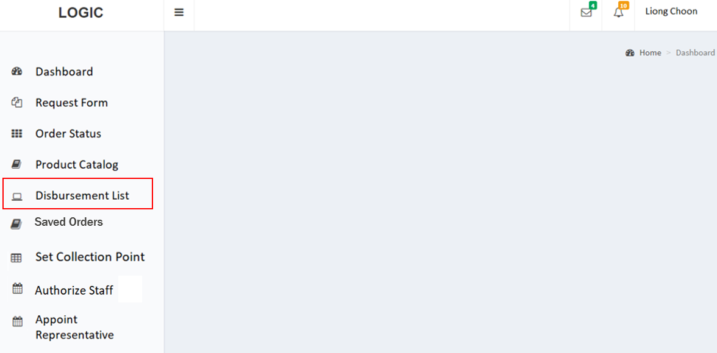

Click on Disbursement List (highlighted in red) to view the list.

The view below will be shown.

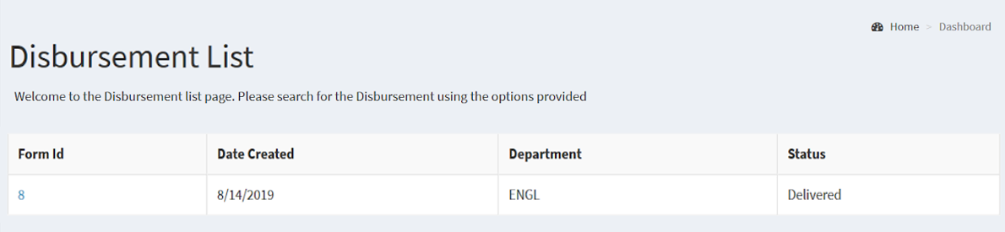

Upon clicking on the ID of the form, the detailed view below will be shown.

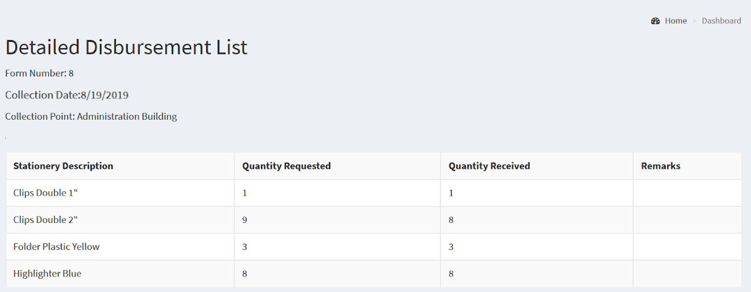

# Saved Orders

To view the saved orders, select the following link from the left panel (Highlighted in Red):

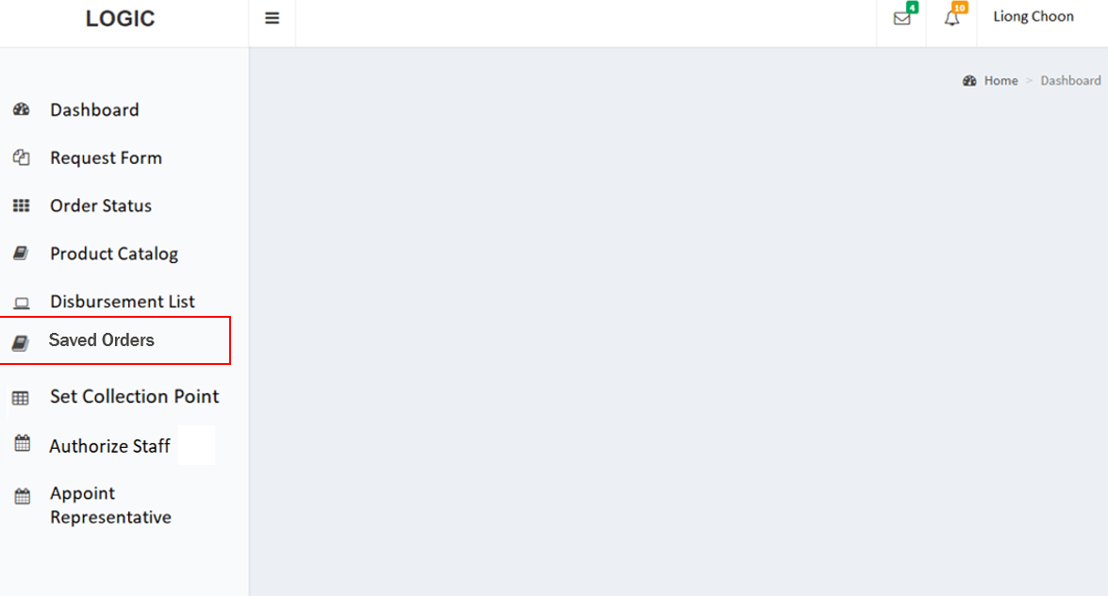

Upon selection of Saved Orders, this will be the screen that would be shown.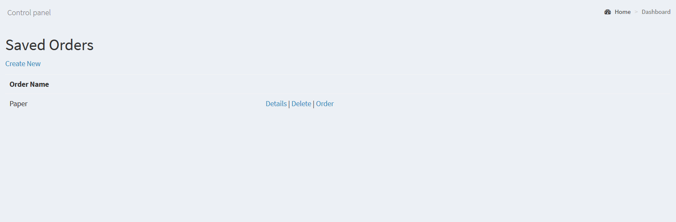

To be able to see the details of the save order, select the option of the details. Upon selection, the details of the order would be shown.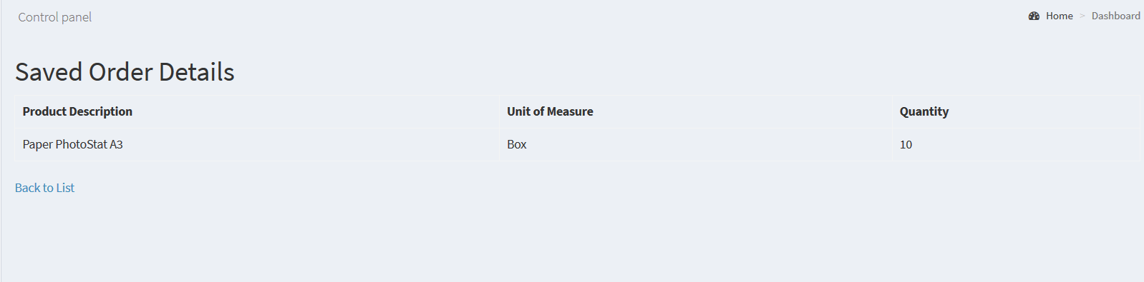

Create Saved Order

To create a new save order, select the create new option on the save orders view.



Upon selecting the option to create a save order, this will be the view that would be shown.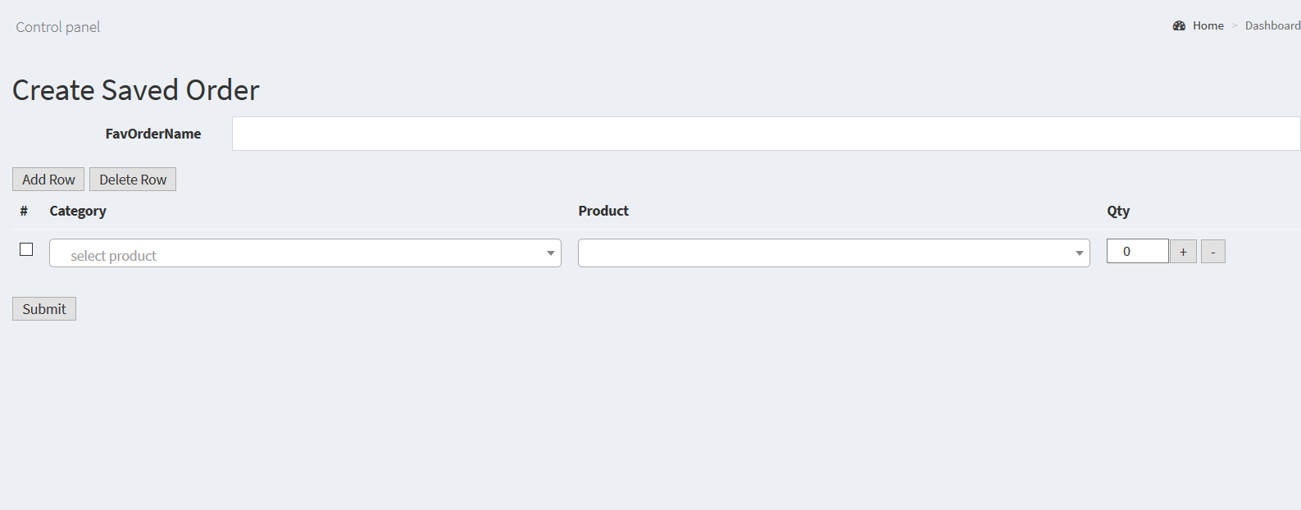

First choose a category by selecting from the dropdown list. A type-ahead search is also provided and you will be able to type a selected category as well.

After selecting a category, the related product lists will be loaded. Here you can choose or type your selection easily as shown in the example below.

You can also name the order so that it would be easier to know which order contains what details.

To add more items to the request form, click “Add Row” at the top left. You will be able to create a stationery request form as shown below.

To adjust quantity for each item, simply click on the “+” and “-” signs or type in the required quantity in the box.

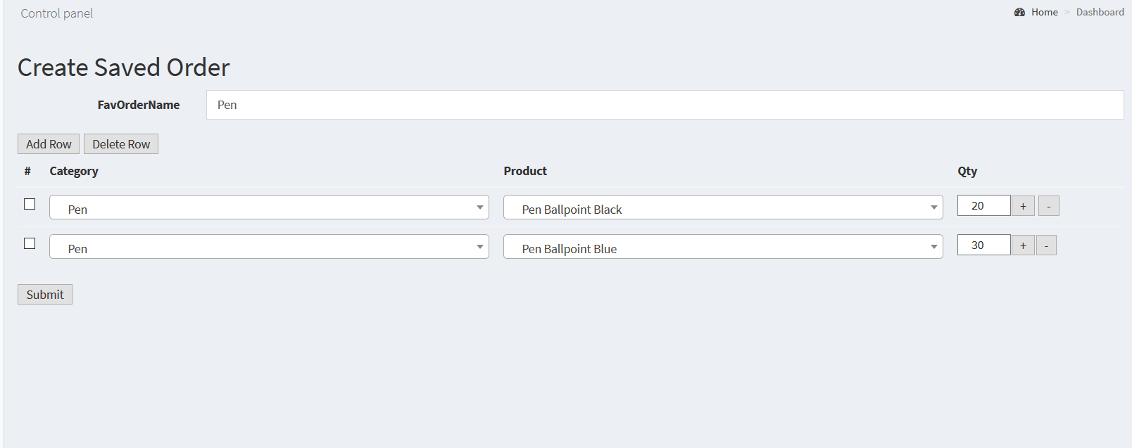

Once all items have been entered, click “Submit” at the bottom to finish the creation of the form.

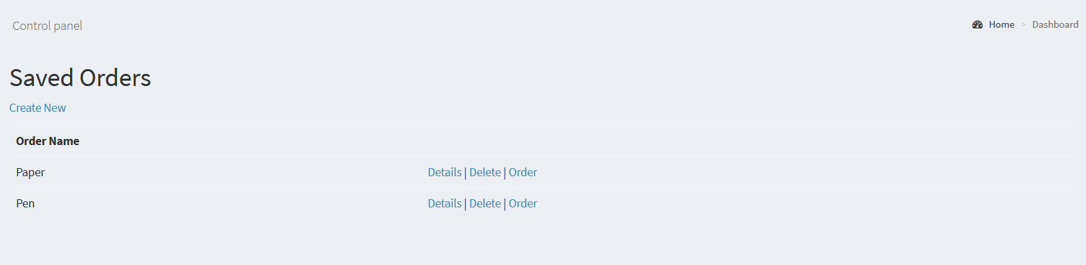

Delete Saved Order

From the saved order view, it is also possible to delete an order.



To be able to delete the save order, select the option of delete. Upon selection, the details of the order would be shown.

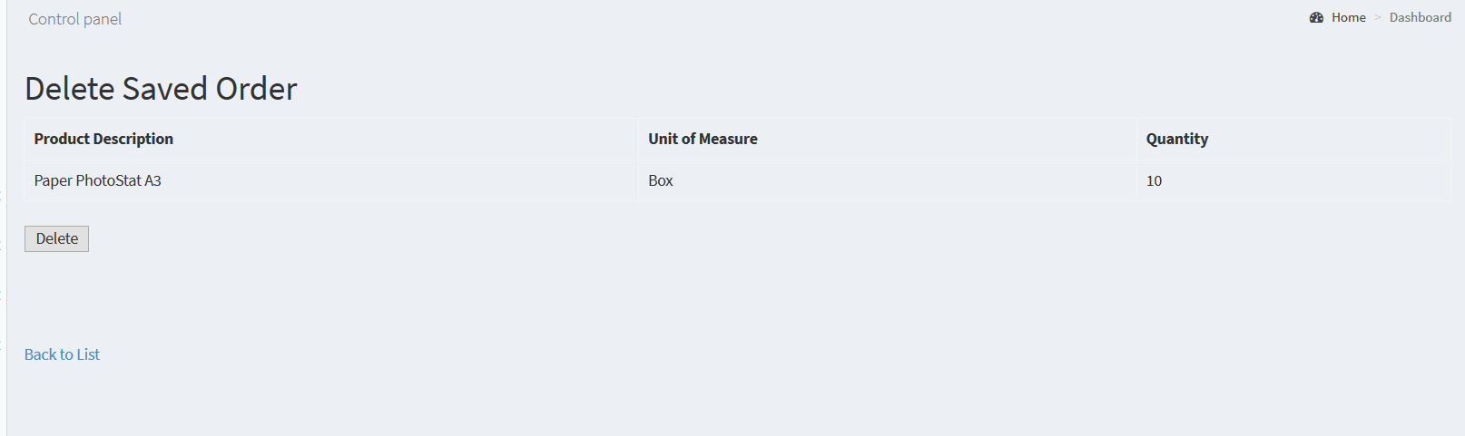

Once you want to delete, click “Delete” at the bottom to finish the deletion of the form. A confirmation option would pop up to confirm the deletion of the order.\

# 

Request Saved Order

From the saved order view, it is possible to send the save order as a request for approval.

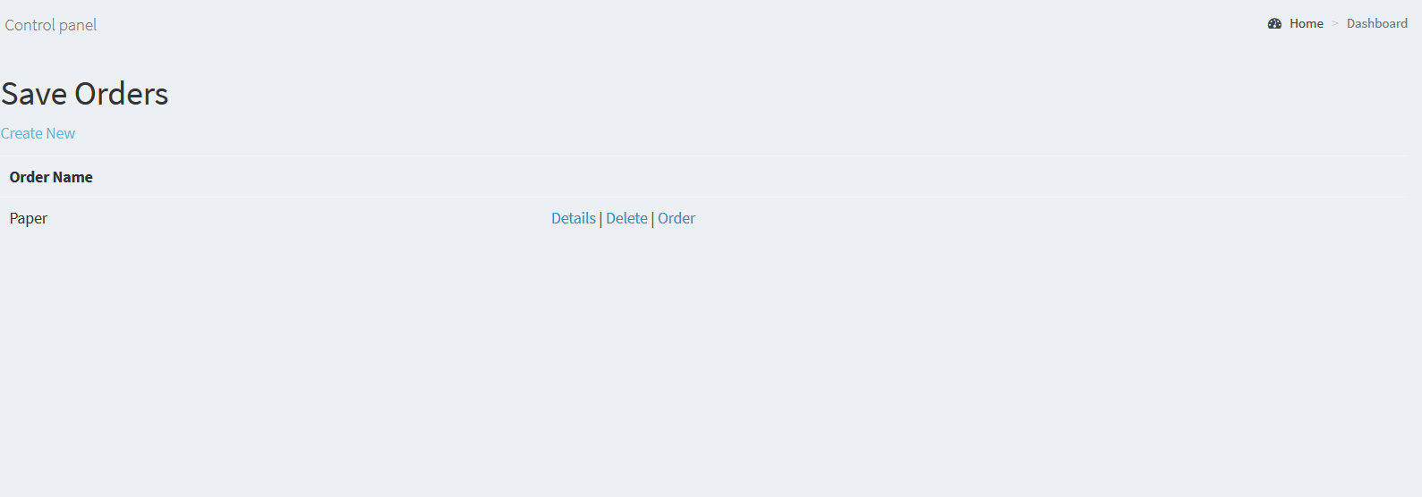

To be able to send the save order as a request, select the option of order. Upon selection, this view will be shown. It will show the details of the request.

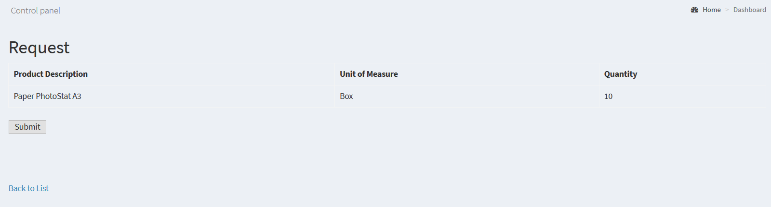

Once you want to submit the order, click “Submit” at the bottom to send the request for approval.

# Appoint Representative

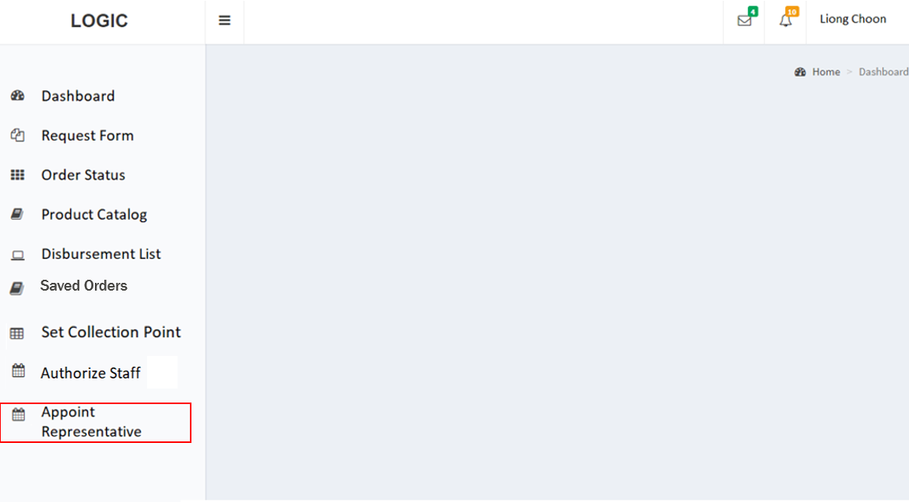

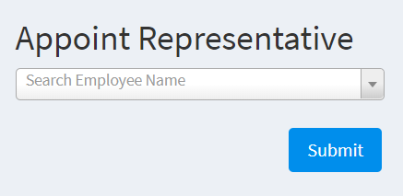

Upon clicking on appointing representative on the dashboard, the screen above will be shown

The system provides the ability for both selection of the dropdown menu as well as typing an employee name in the box for quick search of staff.

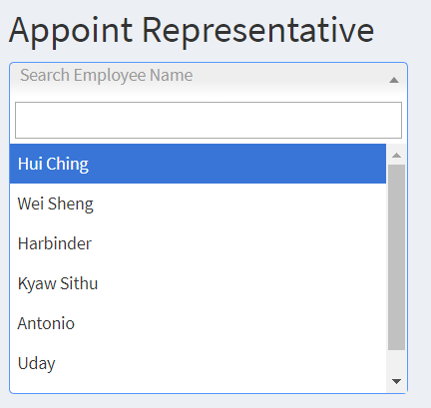

Example, typing “U” will show a list of 3 employee names for selection:

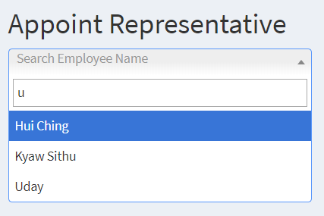

Select the name and once done, press the submit button.

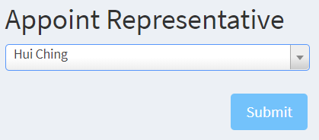

On successful appointment, the system will prompt “Appointment Successful” as shown below:

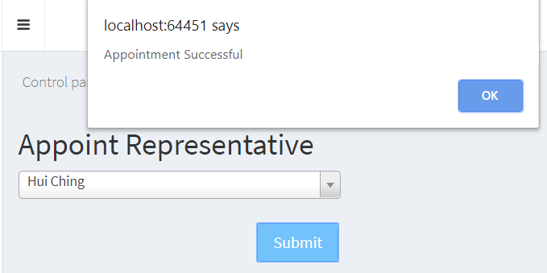

### 

# Authorize Staff

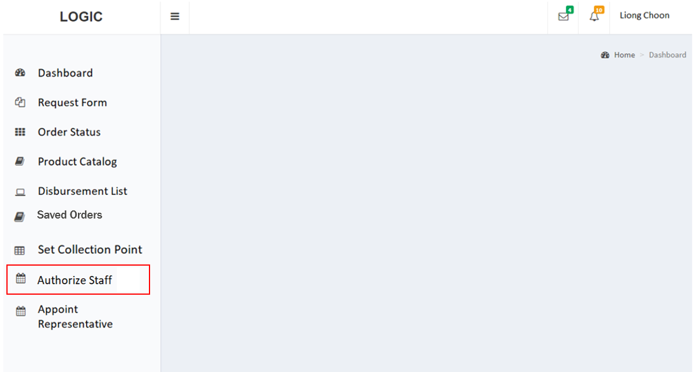

For authorising a representative, click on the Authorize Staff option on the dashboard.

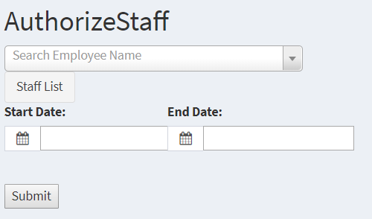

Upon selecting the Authorize Staff option the screen above will be shown.

The system provides the ability for both selection of the dropdown menu as well as typing an employee name in the box for quick search of staff.

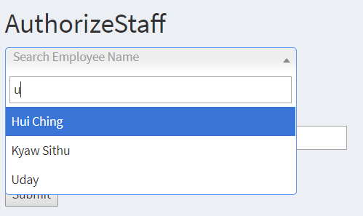

Example, typing the letter “U” will show a list of 3 employee names with the letter for selection.

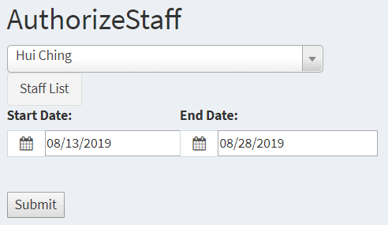

Select the name and the dates. Click on the submit button upon completion.

On successful appointment, the system will prompt “Appointment Successful” as shown below:

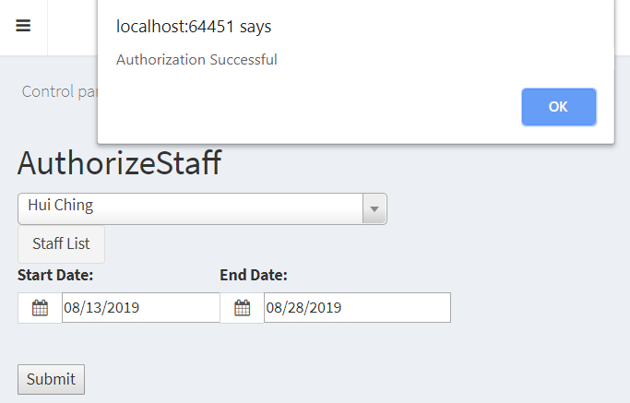

### 

# Set Collection Point

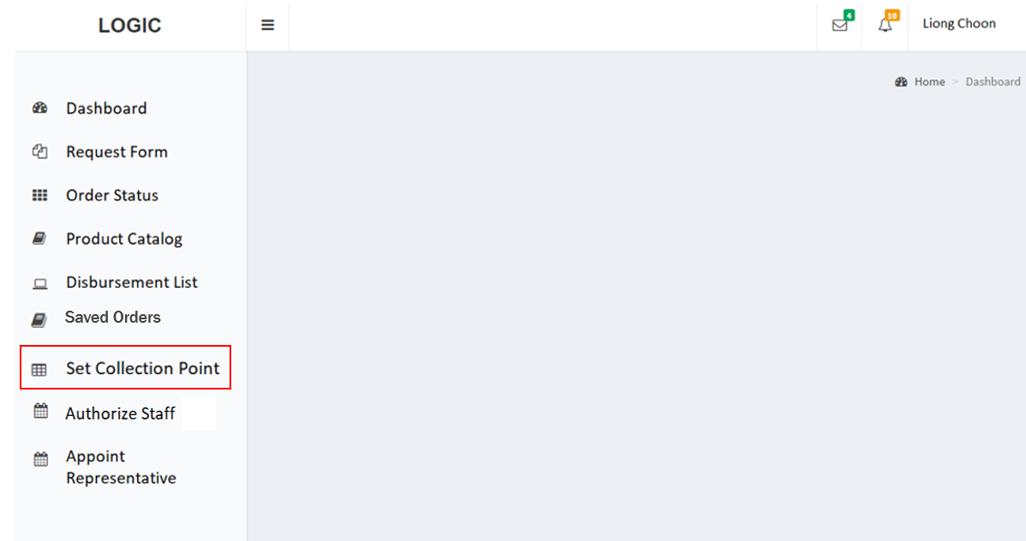

To set the Collection Point, select the following link from the dashboard.

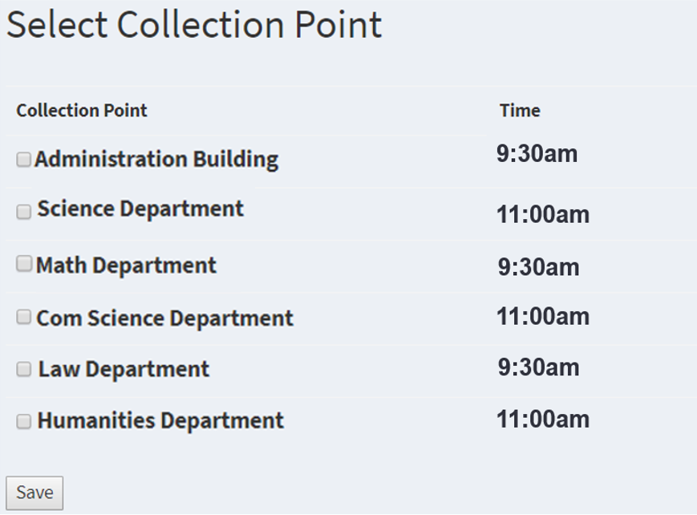

Upon selecting Set Collection Point, the screen above would be shown.

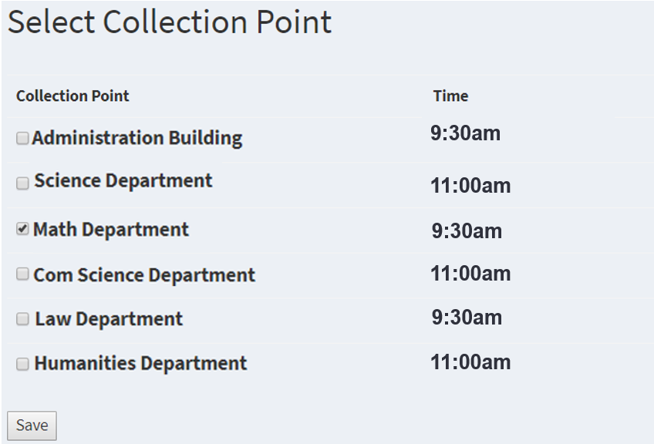

To set a Collection Point, the user has to select one of the boxes. And after clicking on the save button, the Collection Point would be set accordingly.

# Login Screen (Android)

# 

The system will be accessed via the below page. Please enter the provided credentials into the username and password boxes.

# 

Once you are logged in successfully, you will be presented with the following dashboard that shows all available key actions that can be used on the go.

Upon selection of the Log Out button, the user would be redirected back to the Login Screen as shown above.

# 

# Appoint Representative (Android)

To appoint a Department Representative, select the Appoint Representative option.

# 

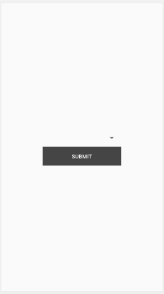

The mobile application allows you to choose an employee from the dropdown list to choose that staff as a representative. Upon completion, click the submit button to update the department representative.

# 

# Authorize Staff (Android)

To grant a staff authorization privileges , select the Authorize Staff option.

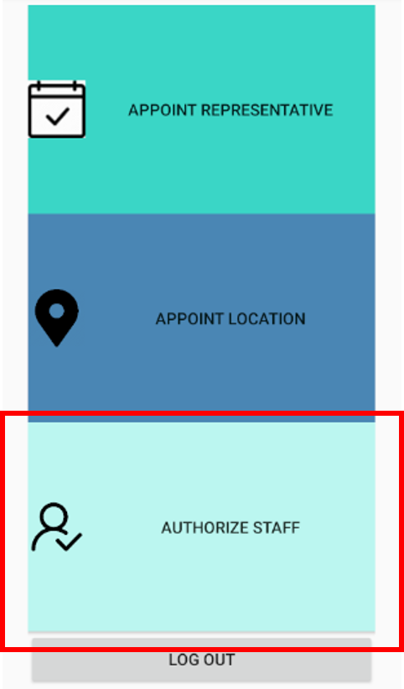

# 

The mobile application allows you to choose an employee from the dropdown list. Next, enter the selected dates to authorize staff for. Upon completion, click the submit button to update the authorized staff and duration.

# 

# Set Collection Point (Android)

To set a collection point, select the Collection Point option.

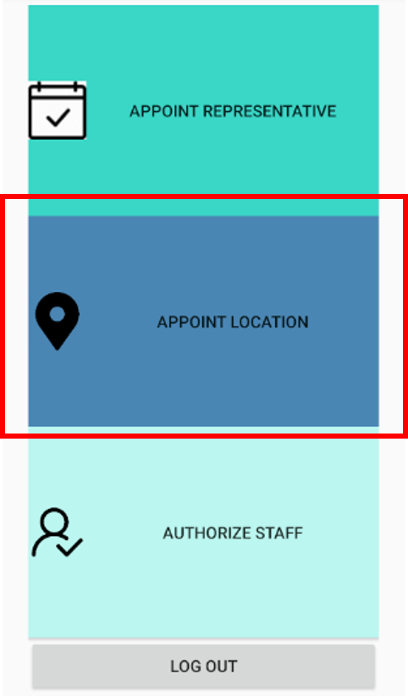

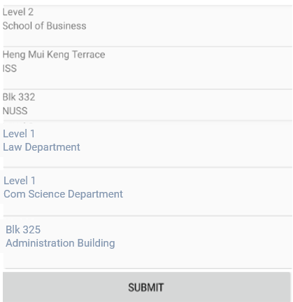

To set a Collection Point, the user has to select one of the options. And after clicking on the submit button, the Collection Point would be set accordingly.